**Team 5**

|  |  |  |
| --- | --- | --- |
| Name | Section | BN |
| Youssef Said Ibrahim Rabie | 2 | 40 |
| Ahmed Alaa | 1 | 6 |
| Abdelrahman Mohamed Salem | 2 | 1 |
| Ahmed Fawzy Mohamed Ibrahim | 1 | 7 |

**Zero Prediction (Show how good is the dataset)**

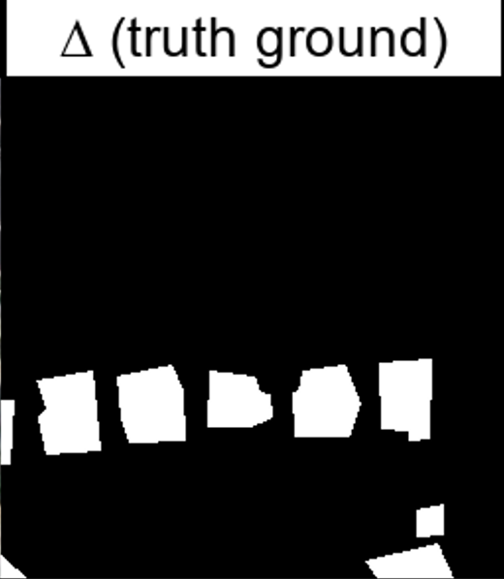We noticed there are many black masks in the truth ground images so we made a model that will always produce black mask no matter what the image looks like. Then ran this model on the whole dataset. We got an average Jaccard index of 0.664. this means that 66.4% of the truth ground images in the whole dataset are just black images. That’s why it will affect our deep learning in a way that it will favor the marking a pixel to be black rather than making it white.

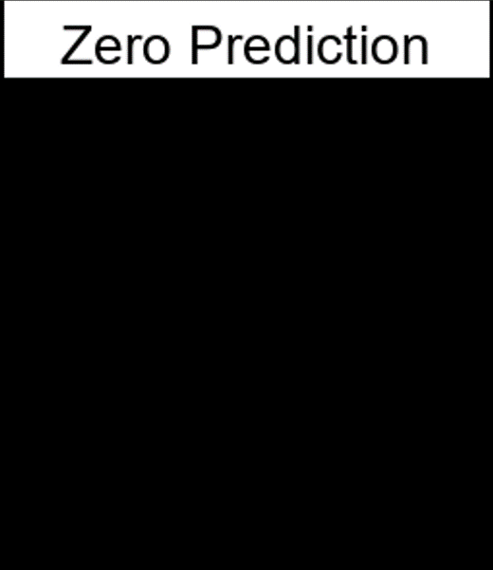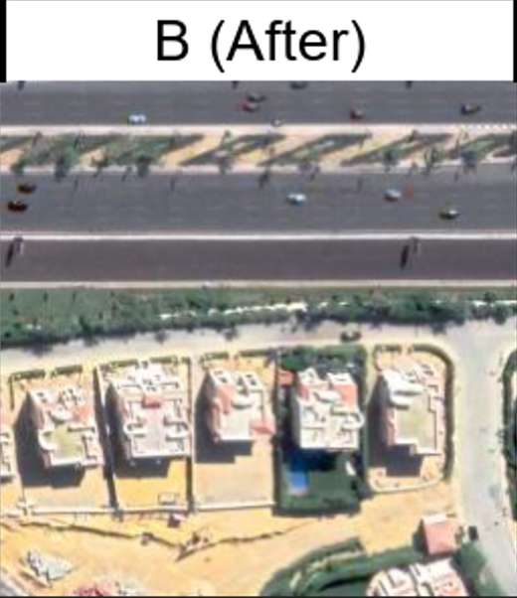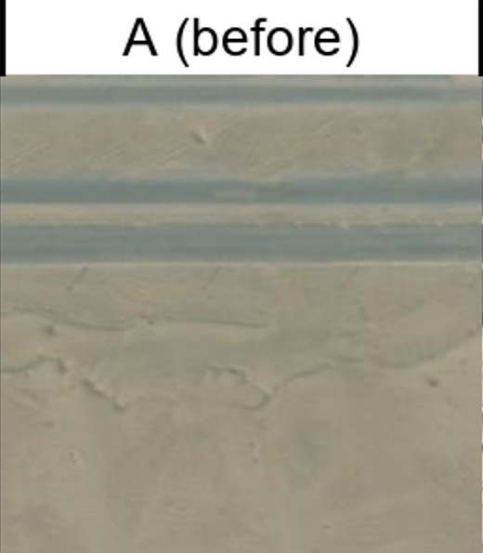

**PCA_Kmeans (Traditional Method)**

We followed these steps from the paper named “Unsupervised Change Detection in Satellite Images Using Principal Component Analysis and k-Means Clustering” by “Turgay Celik” in 2009. We added extra pre and post processing steps to the algorithm introduced to be able to not only detect changes but detect the buildings the appeared. This Algorithm is an unsupervised image processing algorithms, so it does not require any training, so we didn’t have to split dataset (we used the whole dataset as validation and test dataset).

One of the main parameters of this algorithm is a variable called h. We will see its main usage later in the document.

1. 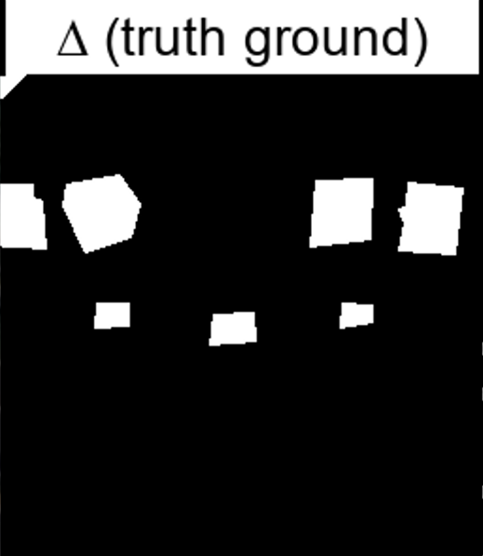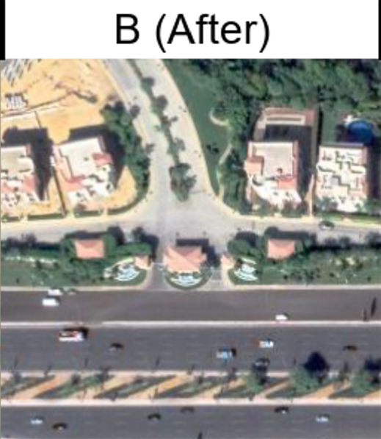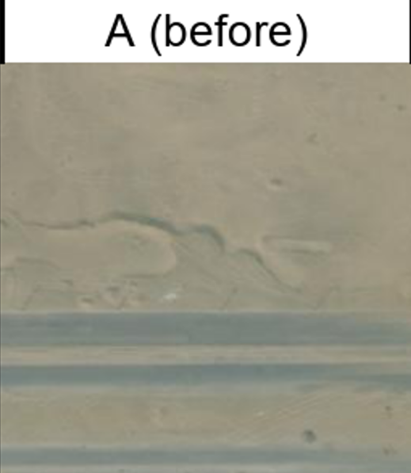We have 2 RGB images A and B, where A represents the before image and B represents the after image.
2. 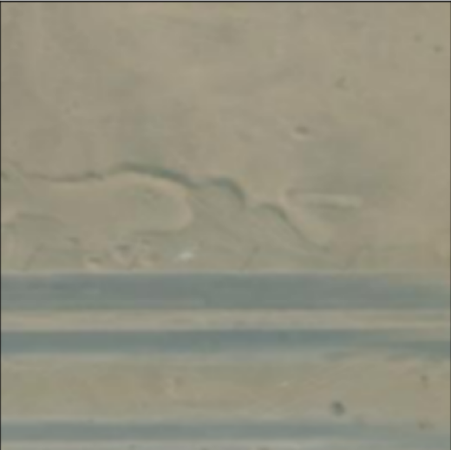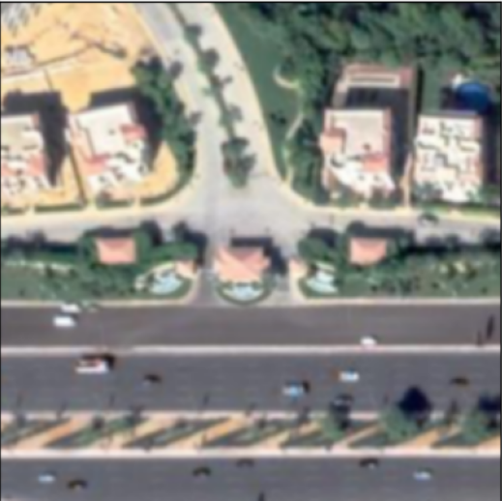Applied Gaussian Blur with Kernal size 3x3 (Pre-processing to remove any noisy pixels in the image).
3. 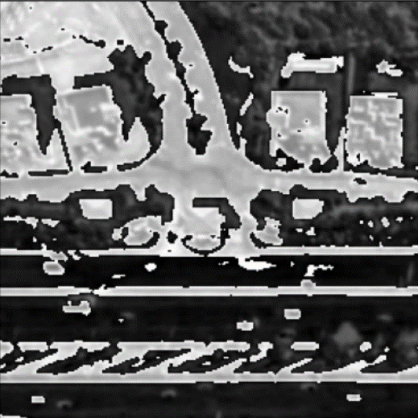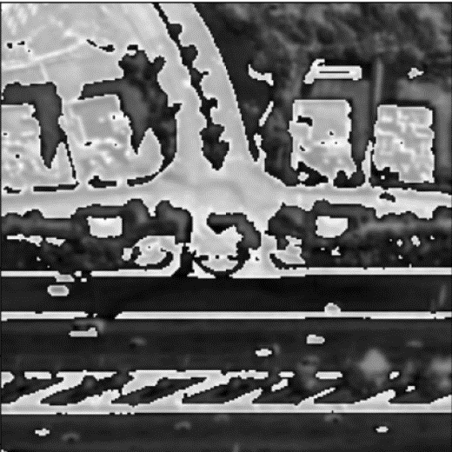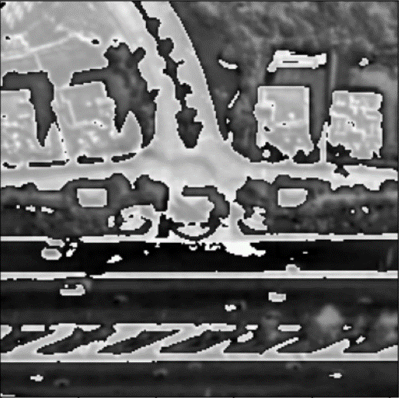Computed the absolute difference between the channels of the 2 images.
4. 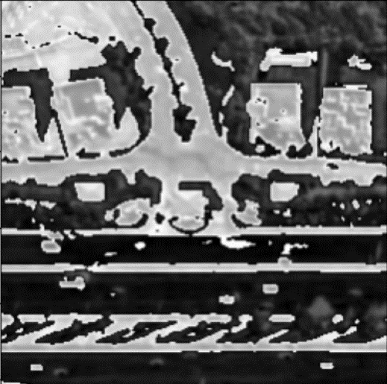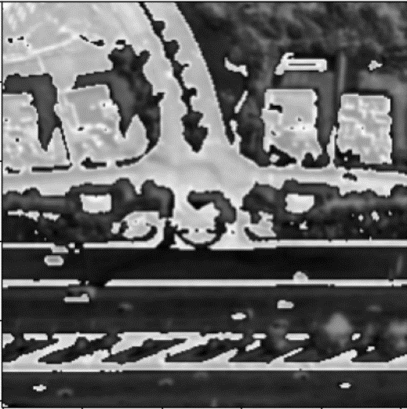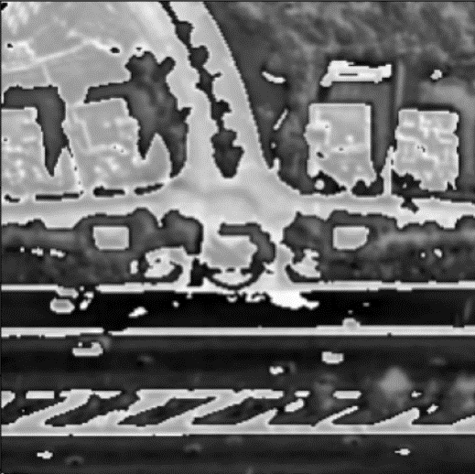Resized the image so that both width and length of the absolute difference image is divisible by h.
5. Represent each channel image by a set of vectors where vectors are flattened non-overlapping blocks of image and the size of each of these blocks is h x h. let’s name these vectors “image vectors”.

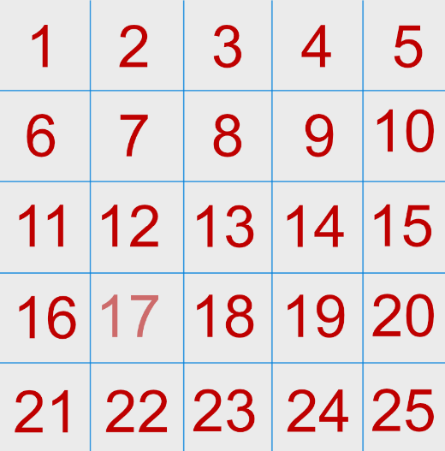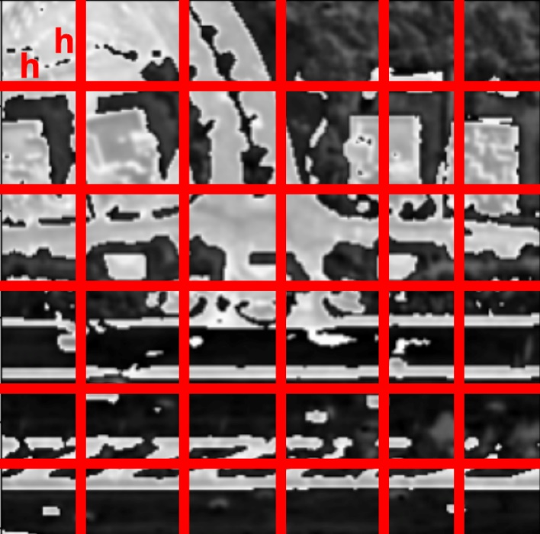

h

h



1. Subtract “image vectors” from their mean so that all the vectors have a mean of 0.
2. Apply PCA on the resulting vectors from the preceding step.
3. 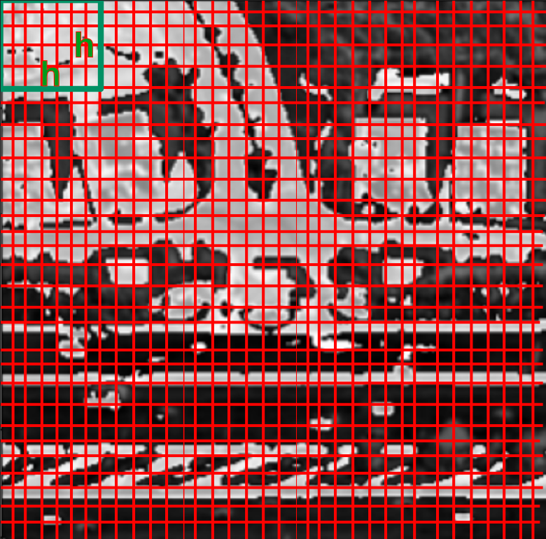Segment each channel image into overlapping blocks of size h x h where each block will represent a pixel then flatten these blocks to find vectors representing pixels. let’s name these vectors “pixel vectors”.

h

h



1. Subtract “pixel vectors” from their mean so that all the vectors have a mean of 0.
2. Project the “pixel vectors” onto PCA eigen vectors.
3. Apply Kmeans with number of clusters = 2. Where the 2 classes will be (pixels changed cluster, pixels didn’t change cluster).
4. 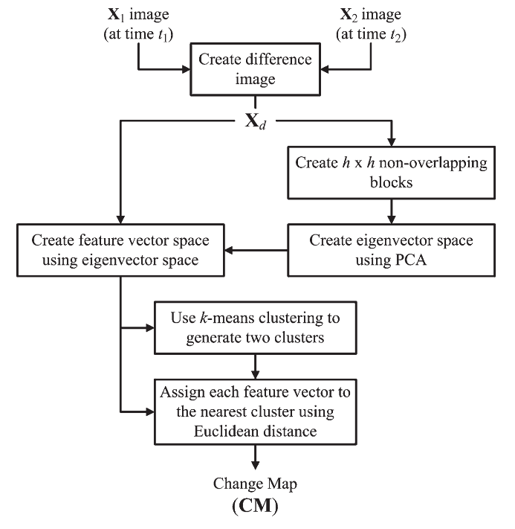The author assumed that that cluster with the smallest size shall be the cluster representing the changed pixels.

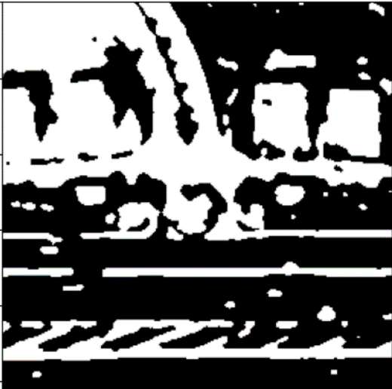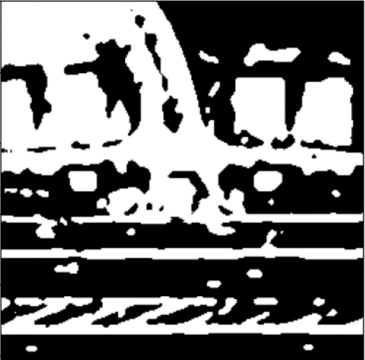

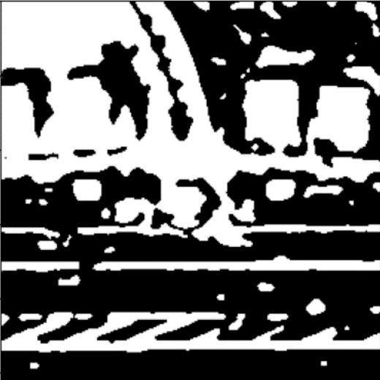

1. After finding pixels that changed in the 3 channels, we applied morphological operation OPENING to remove any small changed pixels with kernel size 5x5. (assuming building size will be big)

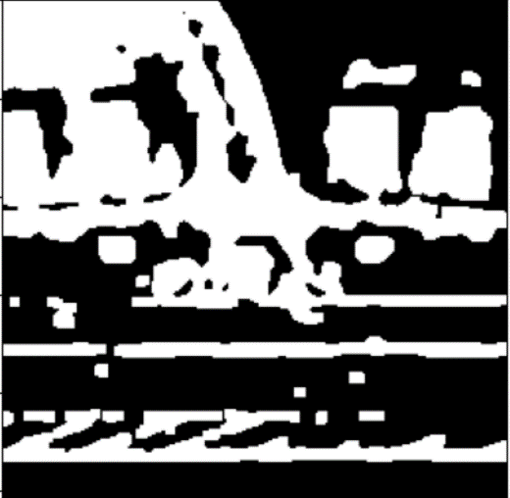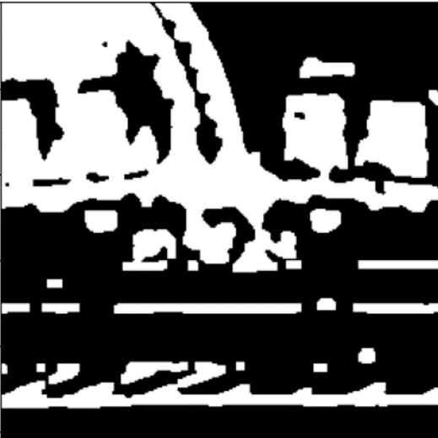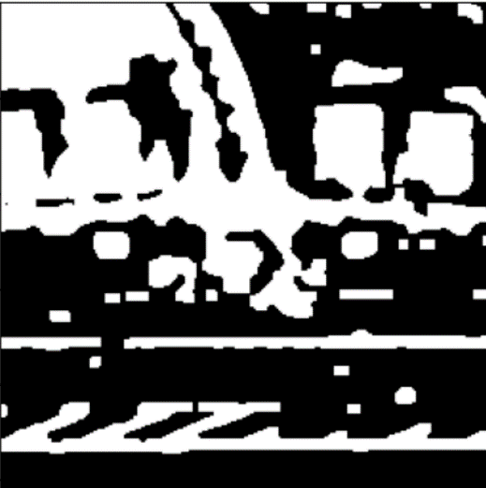

1. 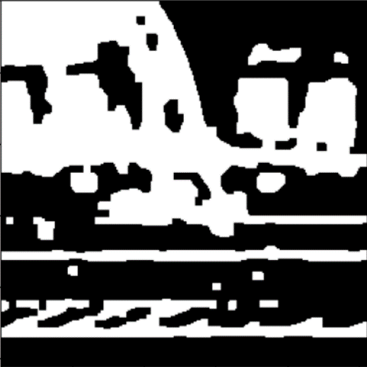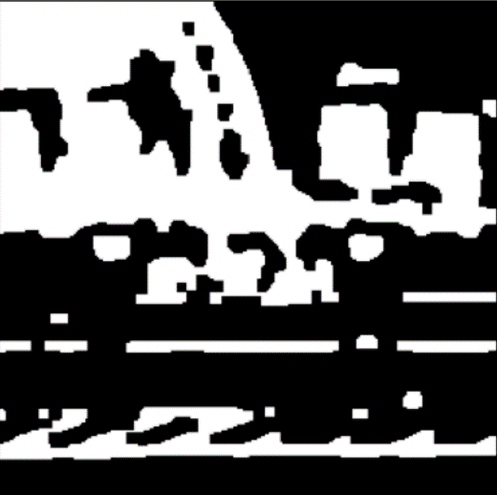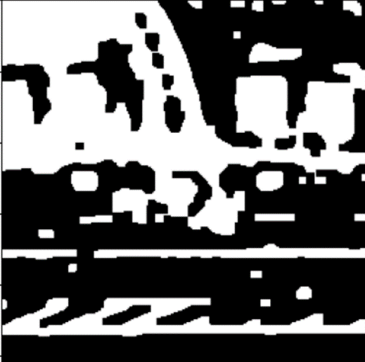Applied morphological operation CLOSING afterwards to fill any small gabs inside big building with kernel size 5x5. (assuming building size will be big)
2. 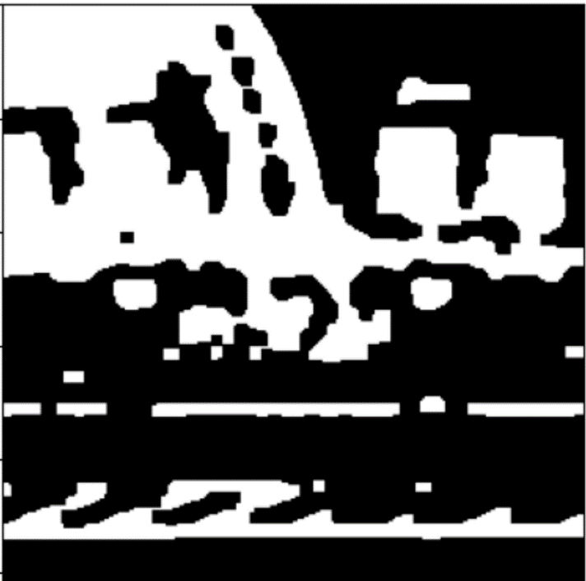We find the intersection between the 3 channels of step 14 assuming that the building pixel has changed all of its 3 channel values.
3. We find all the polygons in the image.

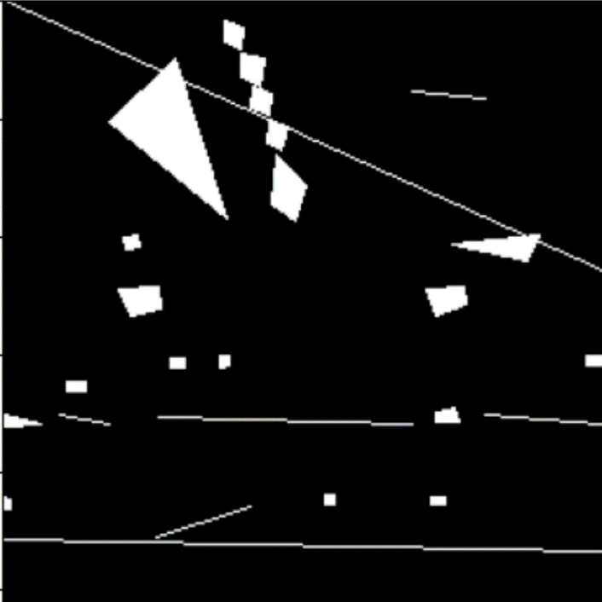

1. find the area of each polygon.
2. find the area of the minimum area rectangle that fits each polygon.
3. Divide both areas by each other and if the division factor is less than a threshold, we can consider this shape a rectangle and thus a building.

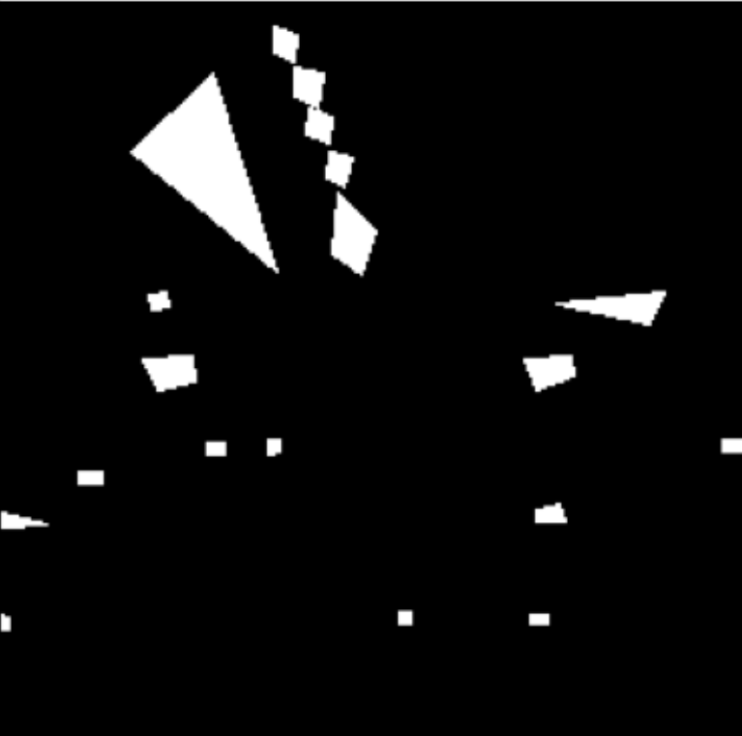

We achieved average Jaccard score on the whole dataset around 40.9%.

**Unet Change Detection (Deep learning Method)**

We followed these steps from the paper named “Unsupervised Change Detection in Satellite Images Using Convolutional Neural Networks” by “Kevin Louis de Jong” and “Anna Sergeevna Bosman” in 2019. The basic idea is a small modification on the normal UNET that was introduced in 2015 by concatenation of difference image to the decoder path instead of the feature vector. We split that dataset into 80% training and 20% testing.

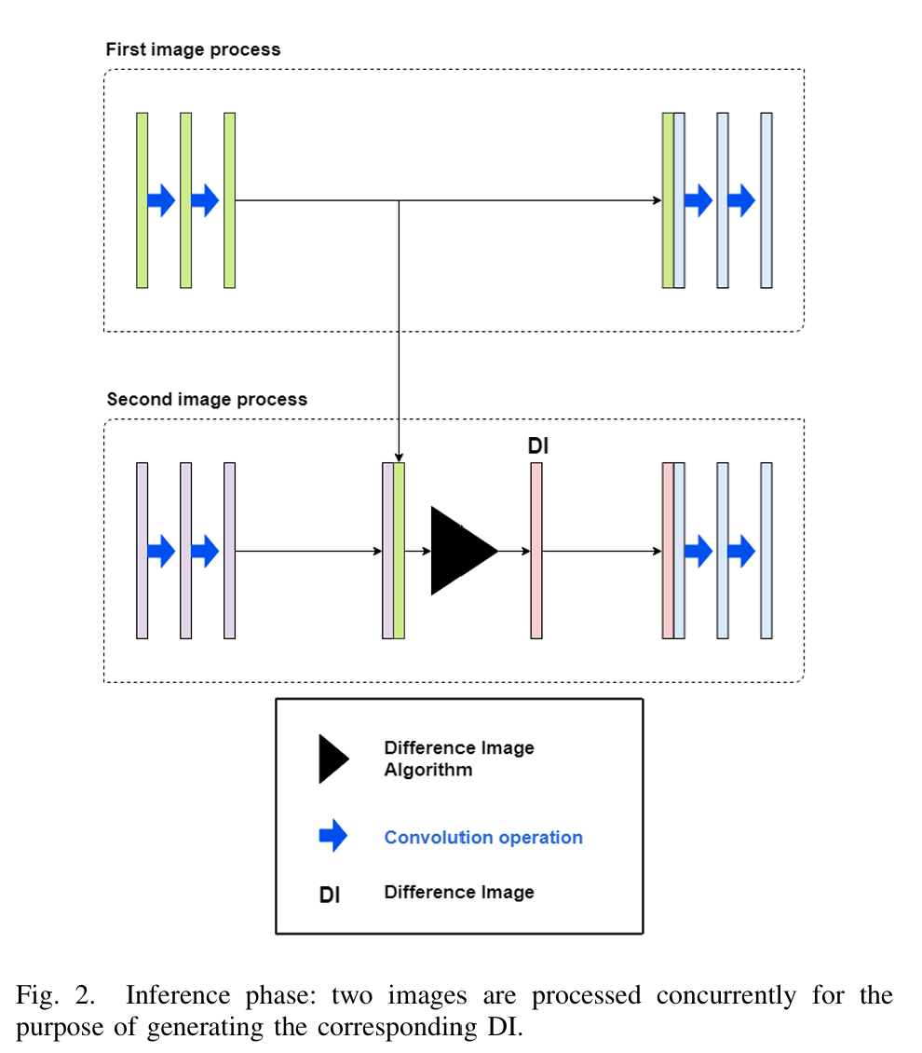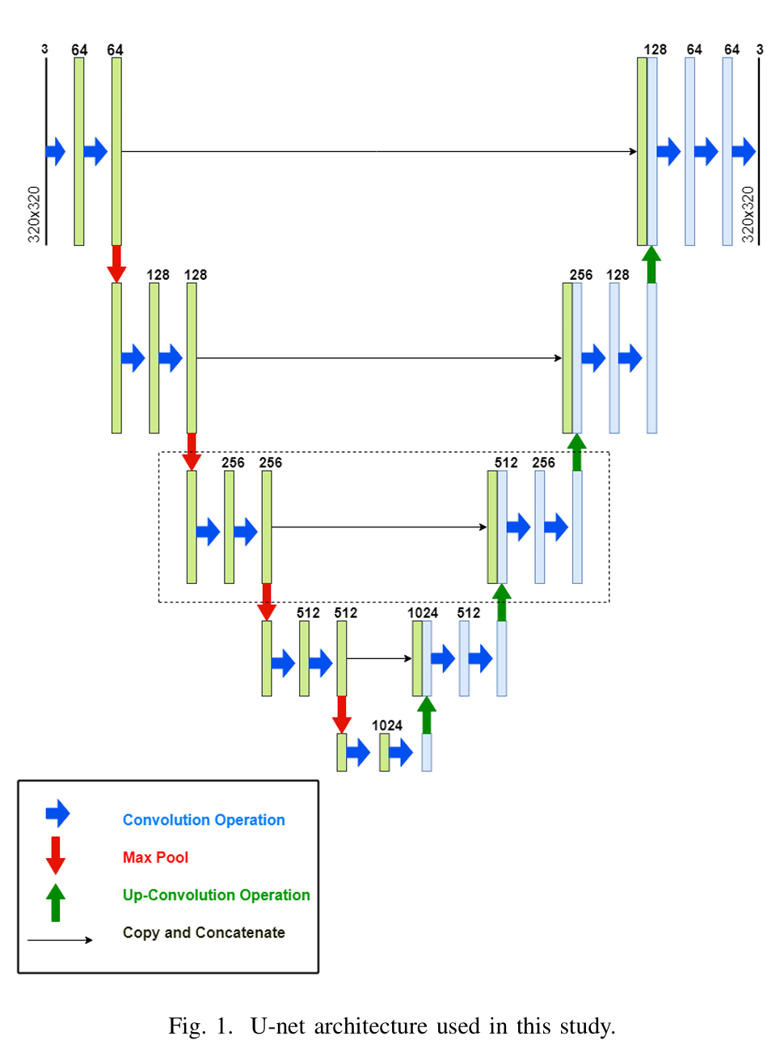

The input to our UNET is 2 images and the output is 1 mask representing pixels where a change in buildings happened. The number of Trainable parameters in our model is 53,378,689 and Average size of model is around 135 MB. Where all the details about architecture implementations are taken from the paper.

The Full Pipeline of the UNET is as follows:

|  |
| --- |
| ----------------------------------------------------------------  Layer (type) Output Shape Param #  ================================================================  Conv2d-1 [-1, 64, 256, 256] 1,792  BatchNorm2d-2 [-1, 64, 256, 256] 128  LeakyReLU-3 [-1, 64, 256, 256] 0  Conv2d-4 [-1, 64, 256, 256] 36,928  BatchNorm2d-5 [-1, 64, 256, 256] 128  LeakyReLU-6 [-1, 64, 256, 256] 0  MaxPool2d-7 [-1, 64, 128, 128] 0  Conv2d-8 [-1, 128, 128, 128] 73,856  BatchNorm2d-9 [-1, 128, 128, 128] 256  LeakyReLU-10 [-1, 128, 128, 128] 0  Conv2d-11 [-1, 128, 128, 128] 147,584  BatchNorm2d-12 [-1, 128, 128, 128] 256  LeakyReLU-13 [-1, 128, 128, 128] 0  MaxPool2d-14 [-1, 128, 64, 64] 0  Conv2d-15 [-1, 256, 64, 64] 295,168  BatchNorm2d-16 [-1, 256, 64, 64] 512  LeakyReLU-17 [-1, 256, 64, 64] 0  Conv2d-18 [-1, 256, 64, 64] 590,080  BatchNorm2d-19 [-1, 256, 64, 64] 512  LeakyReLU-20 [-1, 256, 64, 64] 0  MaxPool2d-21 [-1, 256, 32, 32] 0  Conv2d-22 [-1, 512, 32, 32] 1,180,160  BatchNorm2d-23 [-1, 512, 32, 32] 1,024  LeakyReLU-24 [-1, 512, 32, 32] 0  Conv2d-25 [-1, 512, 32, 32] 2,359,808  BatchNorm2d-26 [-1, 512, 32, 32] 1,024  LeakyReLU-27 [-1, 512, 32, 32] 0  MaxPool2d-28 [-1, 512, 16, 16] 0  Conv2d-29 [-1, 1024, 16, 16] 4,719,616  BatchNorm2d-30 [-1, 1024, 16, 16] 2,048  LeakyReLU-31 [-1, 1024, 16, 16] 0  Conv2d-32 [-1, 1024, 16, 16] 9,438,208  BatchNorm2d-33 [-1, 1024, 16, 16] 2,048  LeakyReLU-34 [-1, 1024, 16, 16] 0  Conv2d-35 [-1, 64, 256, 256] 1,792  BatchNorm2d-36 [-1, 64, 256, 256] 128  LeakyReLU-37 [-1, 64, 256, 256] 0  Conv2d-38 [-1, 64, 256, 256] 36,928  BatchNorm2d-39 [-1, 64, 256, 256] 128  LeakyReLU-40 [-1, 64, 256, 256] 0  MaxPool2d-41 [-1, 64, 128, 128] 0  Conv2d-42 [-1, 128, 128, 128] 73,856  BatchNorm2d-43 [-1, 128, 128, 128] 256  LeakyReLU-44 [-1, 128, 128, 128] 0  Conv2d-45 [-1, 128, 128, 128] 147,584  BatchNorm2d-46 [-1, 128, 128, 128] 256  LeakyReLU-47 [-1, 128, 128, 128] 0  MaxPool2d-48 [-1, 128, 64, 64] 0  Conv2d-49 [-1, 256, 64, 64] 295,168  BatchNorm2d-50 [-1, 256, 64, 64] 512  LeakyReLU-51 [-1, 256, 64, 64] 0  Conv2d-52 [-1, 256, 64, 64] 590,080  BatchNorm2d-53 [-1, 256, 64, 64] 512  LeakyReLU-54 [-1, 256, 64, 64] 0  MaxPool2d-55 [-1, 256, 32, 32] 0  Conv2d-56 [-1, 512, 32, 32] 1,180,160  BatchNorm2d-57 [-1, 512, 32, 32] 1,024  LeakyReLU-58 [-1, 512, 32, 32] 0  Conv2d-59 [-1, 512, 32, 32] 2,359,808  BatchNorm2d-60 [-1, 512, 32, 32] 1,024  LeakyReLU-61 [-1, 512, 32, 32] 0  MaxPool2d-62 [-1, 512, 16, 16] 0  Conv2d-63 [-1, 1024, 16, 16] 4,719,616  BatchNorm2d-64 [-1, 1024, 16, 16] 2,048  LeakyReLU-65 [-1, 1024, 16, 16] 0  Conv2d-66 [-1, 1024, 16, 16] 9,438,208  BatchNorm2d-67 [-1, 1024, 16, 16] 2,048  LeakyReLU-68 [-1, 1024, 16, 16] 0  ConvTranspose2d-69 [-1, 512, 32, 32] 4,719,104  BatchNorm2d-70 [-1, 512, 32, 32] 1,024  Conv2d-71 [-1, 512, 32, 32] 4,719,104  BatchNorm2d-72 [-1, 512, 32, 32] 1,024  LeakyReLU-73 [-1, 512, 32, 32] 0  Conv2d-74 [-1, 512, 32, 32] 2,359,808  BatchNorm2d-75 [-1, 512, 32, 32] 1,024  LeakyReLU-76 [-1, 512, 32, 32] 0  ConvTranspose2d-77 [-1, 256, 64, 64] 1,179,904  BatchNorm2d-78 [-1, 256, 64, 64] 512  Conv2d-79 [-1, 256, 64, 64] 1,179,904  BatchNorm2d-80 [-1, 256, 64, 64] 512  LeakyReLU-81 [-1, 256, 64, 64] 0  Conv2d-82 [-1, 256, 64, 64] 590,080  BatchNorm2d-83 [-1, 256, 64, 64] 512  LeakyReLU-84 [-1, 256, 64, 64] 0  ConvTranspose2d-85 [-1, 128, 128, 128] 295,040  BatchNorm2d-86 [-1, 128, 128, 128] 256  Conv2d-87 [-1, 128, 128, 128] 295,040  BatchNorm2d-88 [-1, 128, 128, 128] 256  LeakyReLU-89 [-1, 128, 128, 128] 0  Conv2d-90 [-1, 128, 128, 128] 147,584  BatchNorm2d-91 [-1, 128, 128, 128] 256  LeakyReLU-92 [-1, 128, 128, 128] 0  ConvTranspose2d-93 [-1, 64, 256, 256] 73,792  BatchNorm2d-94 [-1, 64, 256, 256] 128  Conv2d-95 [-1, 64, 256, 256] 73,792  BatchNorm2d-96 [-1, 64, 256, 256] 128  LeakyReLU-97 [-1, 64, 256, 256] 0  Conv2d-98 [-1, 64, 256, 256] 36,928  BatchNorm2d-99 [-1, 64, 256, 256] 128  LeakyReLU-100 [-1, 64, 256, 256] 0  Conv2d-101 [-1, 1, 256, 256] 577  ================================================================  Total params: 53,378,689  Trainable params: 53,378,689  Non-trainable params: 0  ----------------------------------------------------------------  Input size (MB): 0.00  Forward/backward pass size (MB): 1254.50  Params size (MB): 203.62  Estimated Total Size (MB): 1458.12  ---------------------------------------------------------------- |

We used a batch size of 4 where the size of training data is 3894 images. Each epoch took around 25 minutes to complete. The best loss we could get is 1.3%. The best accuracy we could get on the testing data is 79.8% (at epoch No. 110 and loss on training data was 1.4%) using average Jaccard index where the size of test data is 974 images. The Epoch number at which we stopped at is epoch number 129. Where the training of such UNET took around 54.17 hours. We only begin calculating accuracies after a point where the loss was acceptable, but we don’t use test data in any type of optimization/training the model. The optimizer used is Adam optimizer and the loss function used is Binary Cross Entropy with sigmoid activation function. After some time (after epoch 110), we noticed that the loss is stuck at around 1.3% for around 20 epochs, that’s when we assumed that we reached the global minimum.

The Average Jaccard index on the whole dataset (including training and Testing) is 90.3%.

|  |
| --- |
| Epoch Number: 0, loss: 0.17471466610280822  Epoch Number: 1, loss: 0.14199091476202777  Epoch Number: 2, loss: 0.1307049605438918  Epoch Number: 3, loss: 0.12042065357475769  Epoch Number: 4, loss: 0.11350404719623222  Epoch Number: 5, loss: 0.10678567868816137  Epoch Number: 6, loss: 0.10418169898195173  Epoch Number: 7, loss: 0.10154102344063036  Epoch Number: 8, loss: 0.09619461639520847  Epoch Number: 9, loss: 0.09681554608074738  Epoch Number: 10, loss: 0.09043137947610842  Epoch Number: 11, loss: 0.09122554887611514  Epoch Number: 12, loss: 0.08778136230073869  Epoch Number: 13, loss: 0.08531742462100318  Epoch Number: 14, loss: 0.08513728124602961  Epoch Number: 15, loss: 0.08396289597396762  Epoch Number: 16, loss: 0.08204886507624999  Epoch Number: 17, loss: 0.08123266641002817  Epoch Number: 18, loss: 0.07788623177774776  Epoch Number: 19, loss: 0.07695879778371026  Epoch Number: 20, loss: 0.0773150671296753  Epoch Number: 21, loss: 0.07461446291725271  Epoch Number: 22, loss: 0.07397567353265073  Epoch Number: 23, loss: 0.07110195147118364  Epoch Number: 24, loss: 0.07282069058223174  Epoch Number: 25, loss: 0.07203668586381425  Epoch Number: 26, loss: 0.06936057655755669  Epoch Number: 27, loss: 0.06749881396326833  Epoch Number: 28, loss: 0.06644962163367428  Epoch Number: 29, loss: 0.06421788896651914  Epoch Number: 30, loss: 0.06119485259121762  Epoch Number: 31, loss: 0.0635630344072333  Epoch Number: 32, loss: 0.06183925170000666  Epoch Number: 33, loss: 0.05941628801672218  Epoch Number: 34, loss: 0.0579487271534088  Epoch Number: 35, loss: 0.05860779281007126  Epoch Number: 36, loss: 0.055897489813013145  Epoch Number: 37, loss: 0.0532455685517888  Epoch Number: 38, loss: 0.05475971405648101  Epoch Number: 39, loss: 0.05167587826432935  Epoch Number: 40, loss: 0.05259273568438426  Epoch Number: 41, loss: 0.04742643369125943  Epoch Number: 42, loss: 0.0495780134108216  Epoch Number: 43, loss: 0.04696909153545932  Epoch Number: 44, loss: 0.04727337025368634  Epoch Number: 45, loss: 0.04640071866825635  Epoch Number: 46, loss: 0.044624641416758565  Epoch Number: 47, loss: 0.04636625606106976  Epoch Number: 48, loss: 0.0395877977635395  Epoch Number: 49, loss: 0.04267916032548946  Epoch Number: 50, loss: 0.04036075148665054  Epoch Number: 51, loss: 0.038599751777200694  Epoch Number: 52, loss: 0.039527586821783096  Epoch Number: 53, loss: 0.036022510089507055  Epoch Number: 54, loss: 0.03860302367203612  Epoch Number: 55, loss: 0.03348042369882863  Epoch Number: 56, loss: 0.03476635820545758  Epoch Number: 57, loss: 0.033827092255180616  Epoch Number: 58, loss: 0.03547216569396625  Epoch Number: 59, loss: 0.032490302818358685  Epoch Number: 60, loss: 0.03181324988419268  Epoch Number: 61, loss: 0.03036412198159199  Epoch Number: 62, loss: 0.03203518028242681  Epoch Number: 63, loss: 0.03025976282579508  Epoch Number: 64, loss: 0.029523484432179545  Epoch Number: 65, loss: 0.031800010666554905  Epoch Number: 66, loss: 0.031178366149132414  Epoch Number: 67, loss: 0.02727725324516098  Epoch Number: 68, loss: 0.02928224215034928  Epoch Number: 69, loss: 0.025545205192055363  Epoch Number: 70, loss: 0.026400011608847983  Epoch Number: 71, loss: 0.02656357577568717  Epoch Number: 72, loss: 0.02846442469823113  Epoch Number: 73, loss: 0.024731862069018416  Epoch Number: 74, loss: 0.02802028005623866  Epoch Number: 75, loss: 0.02254212385992548  Epoch Number: 76, loss: 0.02273202372093249  Epoch Number: 77, loss: 0.025751342572440102  Epoch Number: 78, loss: 0.022477793754459036  Epoch Number: 79, loss: 0.022053216487945927, accuracy: 0.7869910427949316  Epoch Number: 80, loss: 0.024805048190197947, accuracy: 0.6907955541043014  Epoch Number: 81, loss: 0.020462346137466784, accuracy: 0.7436567584159638  Epoch Number: 82, loss: 0.026825547118296992, accuracy: 0.6537994087079059  Epoch Number: 83, loss: 0.022409917038482188, accuracy: 0.6840106076513264  Epoch Number: 84, loss: 0.019118333191589232, accuracy: 0.7672067348193526  Epoch Number: 85, loss: 0.020251649564919576, accuracy: 0.7617529957171347  Epoch Number: 86, loss: 0.019782174667803375, accuracy: 0.7219969644730446  Epoch Number: 87, loss: 0.02722662753700626, accuracy: 0.7567429156590346  Epoch Number: 88, loss: 0.019142074202814583, accuracy: 0.774129668128886  Epoch Number: 89, loss: 0.019226005152195285, accuracy: 0.7046181426563597  Epoch Number: 90, loss: 0.02144231983046689, accuracy: 0.7672622234385005  Epoch Number: 91, loss: 0.01812967308697131, accuracy: 0.7785455402332744  Epoch Number: 92, loss: 0.018764672111809398, accuracy: 0.7466231905208605  Epoch Number: 93, loss: 0.020013407093323714, accuracy: 0.7651935727007493  Epoch Number: 94, loss: 0.021485326976842956, accuracy: 0.7517801207040218  Epoch Number: 95, loss: 0.01763455447283027, accuracy: 0.7833356918543678  Epoch Number: 96, loss: 0.016019435809745724, accuracy: 0.7920859274596624  Epoch Number: 97, loss: 0.017902836229308702, accuracy: 0.7559186967999327  Epoch Number: 98, loss: 0.016589173903125462, accuracy: 0.7411334146869094  Epoch Number: 99, loss: 0.018863177647579457, accuracy: 0.7761943500161986  Epoch Number: 100, loss: 0.015854322590047768, accuracy: 0.7271847571124899  Epoch Number: 101, loss: 0.01855422941511372, accuracy: 0.769073589107627  Epoch Number: 102, loss: 0.016244728196780227, accuracy: 0.7787071870368447  Epoch Number: 103, loss: 0.01925076852685752, accuracy: 0.7370219883984259  Epoch Number: 104, loss: 0.017273170100691994, accuracy: 0.785366661200586  Epoch Number: 105, loss: 0.016334658692242394, accuracy: 0.747247270718485  Epoch Number: 106, loss: 0.01476667620485573, accuracy: 0.7683090719323502  Epoch Number: 107, loss: 0.015077765135101333, accuracy: 0.7266526493216285  Epoch Number: 108, loss: 0.014437564531791186, accuracy: 0.759088149836224  Epoch Number: 109, loss: 0.01446279214243567, accuracy: 0.7983807751551625  Epoch Number: 110, loss: 0.01331067952809136, accuracy: 0.7662518140769952  Epoch Number: 111, loss: 0.013293619061328988, accuracy: 0.7868450819217254  Epoch Number: 112, loss: 0.013248386818644903, accuracy: 0.7700389718219534  Epoch Number: 113, loss: 0.013306120334469037, accuracy: 0.739332749647138  Epoch Number: 114, loss: 0.013282486230157538, accuracy: 0.7773041188669914  Epoch Number: 115, loss: 0.013285523185285199, accuracy: 0.7383100974837852  Epoch Number: 116, loss: 0.013308286097464869, accuracy: 0.778420286732594  Epoch Number: 117, loss: 0.013252660052372588, accuracy: 0.7646779380758932  Epoch Number: 118, loss: 0.013279916829056814, accuracy: 0.7732039066478488  Epoch Number: 119, loss: 0.01324253241493119, accuracy: 0.7592502010050094  Epoch Number: 120, loss: 0.01329216821672162, accuracy: 0.7646928063582472  Epoch Number: 121, loss: 0.013258468697189621, accuracy: 0.7464283438402518  Epoch Number: 122, loss: 0.013256829387661267, accuracy: 0.7712372280553632  Epoch Number: 123, loss: 0.013229919829855368, accuracy: 0.7726134172994895  Epoch Number: 124, loss: 0.013220536708694197, accuracy: 0.7944397577941694  Epoch Number: 125, loss: 0.0133429440978216, accuracy: 0.7817902949890775  Epoch Number: 126, loss: 0.013311653138790484, accuracy: 0.7441484583440446  Epoch Number: 127, loss: 0.013336575514767902, accuracy: 0.7790645996373085  Epoch Number: 128, loss: 0.0132588277182661, accuracy: 0.7778985279360849  Epoch Number: 129, loss: 0.013352043190783055, accuracy: 0.750840650250314 |

**Comparison Examples**

